User Guide Indoor Interactive 32" 4K BizetBeeBoard® SBM

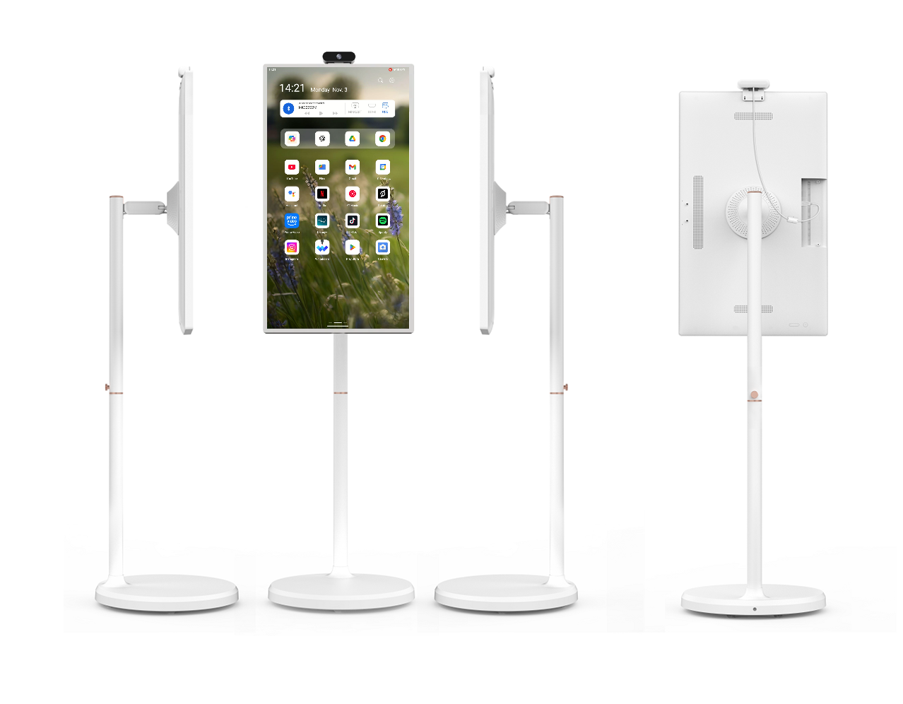
This user guide is for reference only and does not provide any form of guarantee. The trademarks and names mentioned in this user guide belong to the manufacturer.
This user guide is a draft version as a client you are responsible for writing your own set of instructions for your customers. Our user guides may be subject to modification or change without prior notice.
Before you start:
1) Power - Make sure there is power to location, of the correct voltage for the appliance and enough amps. Always consult a qualified electrician for safe installation practices.
2) Installation: The display needs to be installed on a flat solid base or a wall that can take the installed weight of up to 100 kilograms, and you must use the provided bracket or stand. We have suggested basic practices in the user guide for safe handling and lifting advice. You should use safe lifting apparatus that can take the weight of your product. Consider your local regions health and safety advice which supersede this guide handling instructions of your local region. Make sure to carefully site the location in an area designated safe to work and is cordoned off.
3) Network connection. Please make sure you have a good internet connection and test the speed for upload and download to be able to open a web browser and upload and download content to the product and that you know your Wi-Fi password.
4) Kill the risk: make sure you install in a safe environment, away from hazards. Always make sure that you consult your partner who sold you the goods when you are not sure of how something is to be managed.
Think before you lift
Plan how to lift the display into position. Where is the load going of the display going to be placed? Will you need help with the load? Only ever lift in to position a display with two persons. Never work alone to install the display on to a wall or onto the stand.
Remove obstructions, such as discarded wrapping materials. For long lifts, such as from floor to shoulder height, consider resting the load midway on a table or bench to change your grip on it.
Always consider when lifting:
1) Individual capability
2) The nature of the load
3) Environmental conditions
4) Training
5) Work organisation
Packaging
Firstly, after opening the package, please cross reference with the packing list to make sure all component parts are inside the box. Please read the User guide carefully before using this product, and have a detailed understanding of the basic operation, troubleshooting and maintenance to avoid unnecessary troubles and faults. If the product is damaged, please note on the delivery note within 4 hours so that any shipping goods in transit insurance will pay for the display to collection or and salvage. Always return ship to Reseller all items for recycling.
Before installing the display, please read and understand all preventive measures and matters needing attention that are labelled in the user guide and product, and fully grasp its operation procedures.
If the operation, inspection, and maintenance is beyond the specifications in the User guide, please first consult your partner or reseller for advice, otherwise Reseller is not responsible for any accidents, replacement or damages caused.
During the term of Warranty, if you have any problems that requires our advice and support, please contact reseller.
We reserve the right to modify the specifications and designs of the product and use alternative materials under necessary and appropriate circumstances (the modification and change will not affect the quality, use purpose and appearance of the product).
ALWAYS DISCONNECT MAINS BEFORE OPENING COVERS.
The configuration of each partner reseller is device is different, the port type, silk print and number of ports will be slightly different. This operation guide is only for the introduction of commonly used ports. The input or output sources are only examples. The specific port type is subject to the actual product.
Notes
1. Please unplug the power supply before cleaning the screen to ensure the Display is powered off.
2. Please use a clean, soft lint free cloth without thread to lightly wipe the screen and do not use spray directly on the screen any cleaning solutions or water at any time.
3. Do not expose the product to moisture/rain at any time. This is an indoor only display product.
4. Do not block the vents and audio holes on the chassis of the Display. Do not expose the product to air diffuser, heat source or any other equipment that may affect the ventilation.
5. Do not dismantle or repair Display to avoid high-voltage electric shock. Please email reseller for any RMA Repair requirements.
6. You display is supplied with an IEC Power cable with fuse. Please make sure your fuse ratings are correct for the region of operation and the safe use of the display.
7. As the Display maybe used in a variety of locations, it is important to note where voltage might not be stable, to avoid causing damage to the product we suggested to use commercial power and it must not be shared with another high-power equipment. If it is used in the place with unstable voltage, such as an underground station, hospital or office, please make sure to use associated voltage regulation equipment to keep the voltage stable otherwise it may lead to damaging the Display.
8. If the Display is being kept in storage for a longer period of time, please make sure the power supply is unplugged, and carry out dust and moisture proof measures using silica gel and potentially vacuum air tight sealed packaging.
9. If your product is at any time requiring support or stops working contact reseller for an RMA number and you will need to return the display and any accessories in their original packaging to the return address given at the time of RMA return. At no time will Reseller accept goods to be returned without prior notification and an RMA number being given to the customer.
Non-warranty Scope
1. Damages caused by accident, misuse, fire, lightning, water, or other natural accidents, unauthorized modification of the product or use without reading the attached installation of the product will invalidate your warranty.
2. Damages caused by repair by the unauthorized personnel will invalidate your warranty only Reseller may under RMA warranty repair the item.
3. Damages caused to the goods in the process of transportation will invalidate your warranty and shall require the couriers collection, insurers assessment by the manufacturers approved providers and maybe returned at customers cost under RMA for salvage value and WEEE directive disposal.
4. Damages caused in move or during the installation if not conducted as per the instructions will invalidate your warranty.
5. Damages caused by reasons beyond the product, such as power supply changes or blacking out the display due to damaging the internal parts will invalidate your warranty.
6. If other Accessories not in conformity with the product specifications are being used or supplied with the display it will invalidate your warranty
7. The serial number label is damaged, modified or torn will invalidate your warranty.
﻿8. Any other causes of damage not related to the product.

Drawing
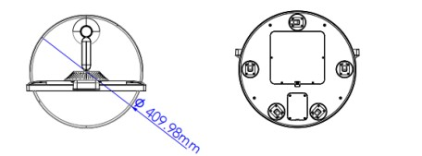
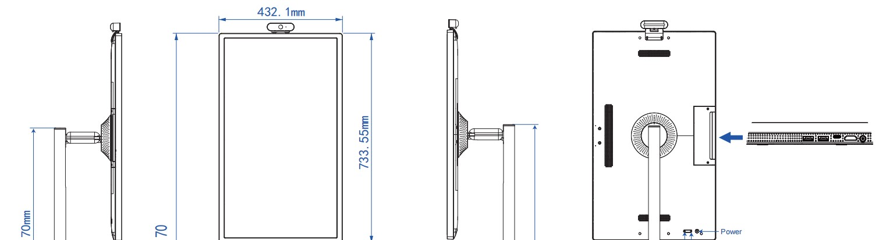
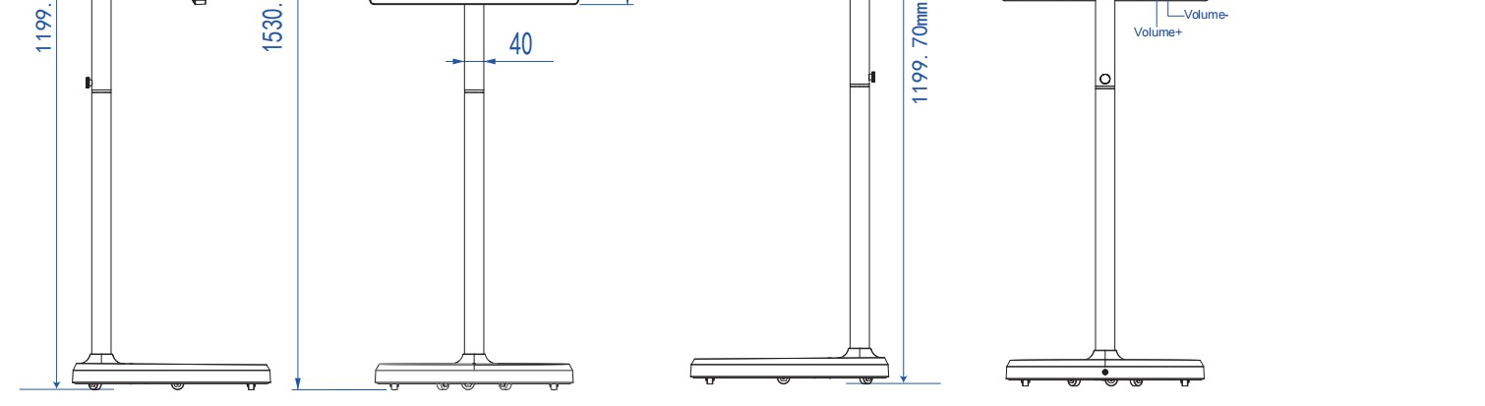

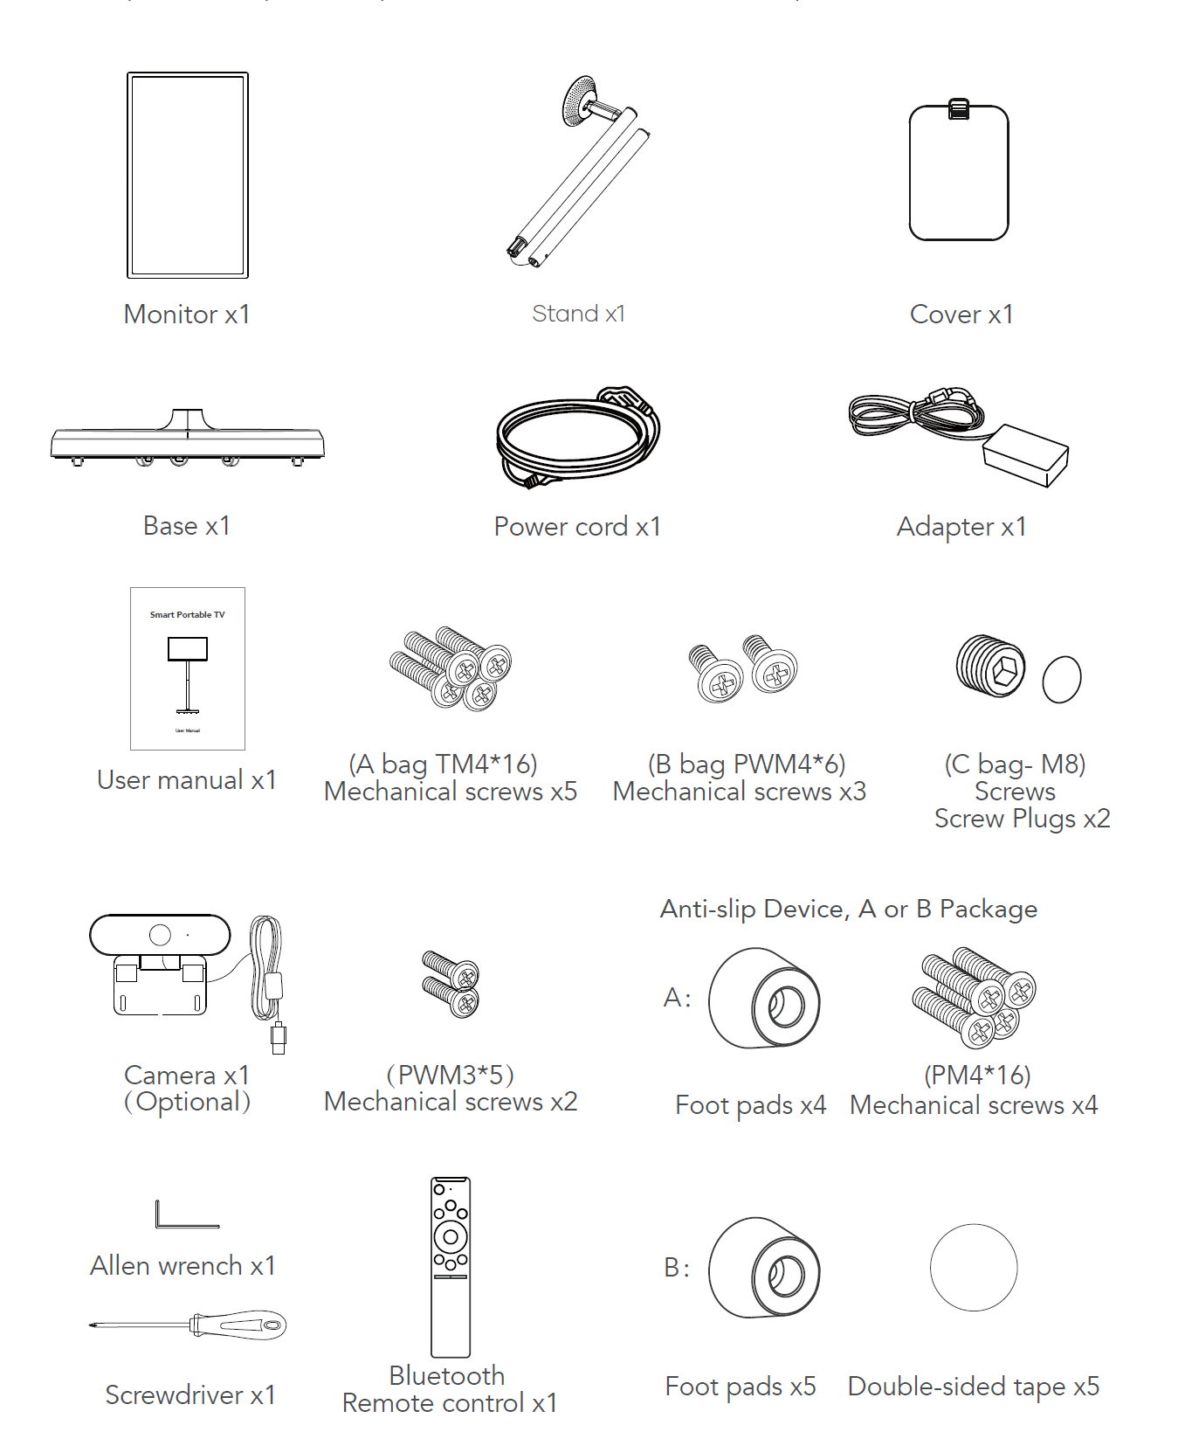
Inventory List:

Battery Stand Assembly Instructions
Step 1
Make sure all component parts are present as per Inventory List above.
First remove the base of the stand from packaging. Turn it upside down and open the bottom cap as per images below:

1a 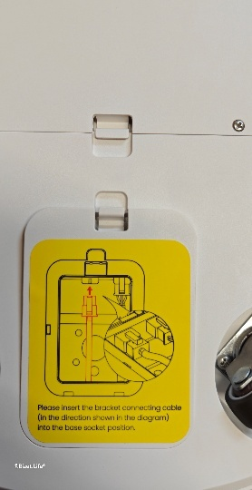 1b 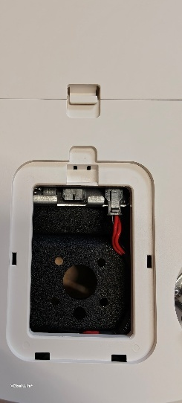
Step 2
Using the screws marked A M4x16 fix the stand pole into the base and plug in the power cable as below images:

2a 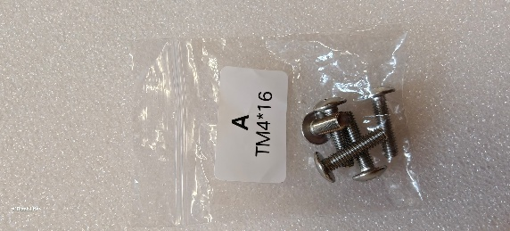 2b 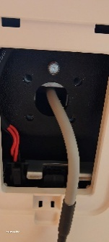 2c 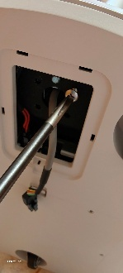 2d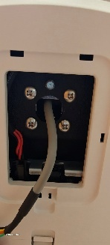 2e 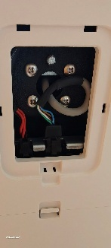 2f 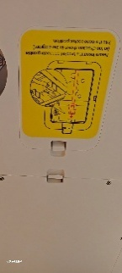
Step 3
Connect middle of the pole together using the M8 in bag C and the Allen Key provided as per image below:
3a 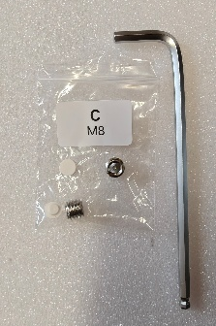 3b 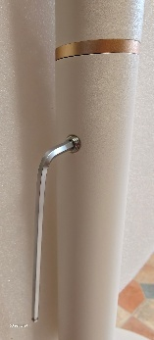 3c  3d 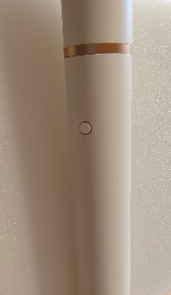
Step 4
Remove the circular cover of the stand vesa mount by pushing the magnetic part off the metal plate as below images:
4a 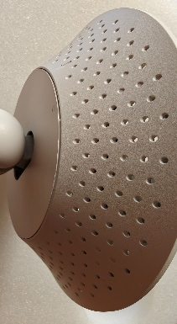 4b 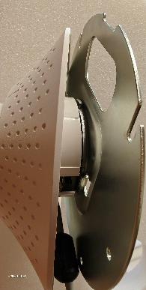 4c 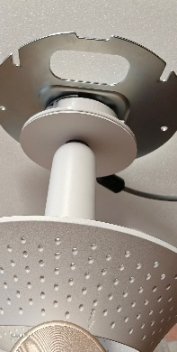
Step 5
Remove the display from packaging and by using the pack B M4x6 fix the display onto the stand vesa bracket as per below images (Note remove the small cover off the back of display before fixing the screws to be able to connect the power cable).
5a 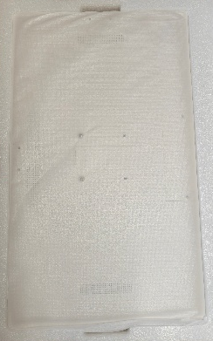 5b 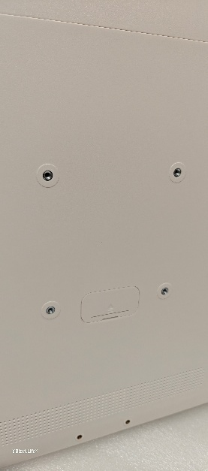 5c 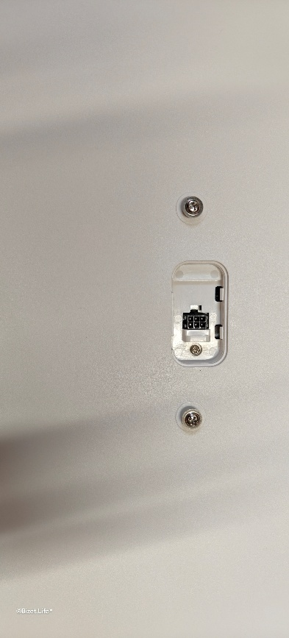
5d 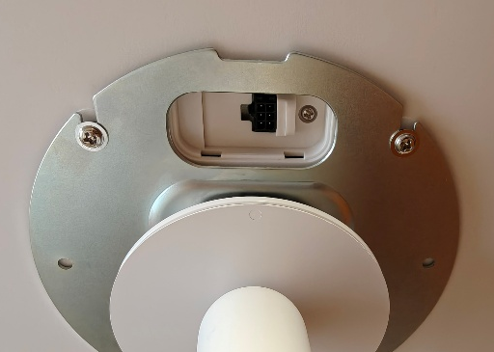 5e 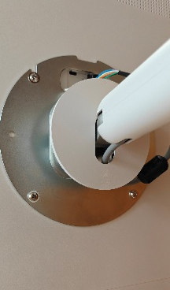
Step 6
Connect the power cable from the stand to the display by plugging it into the port the add the circular cover on as per below image:
6a 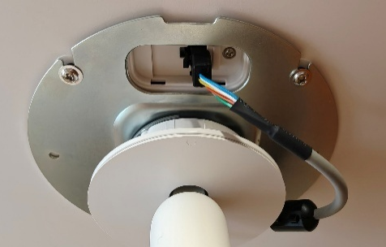 6b 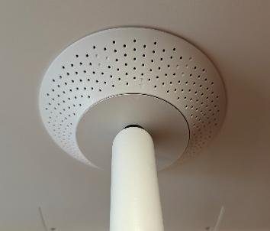
Step 7
To access the ports remove the 2 screws on the back of display as per below image:
7a 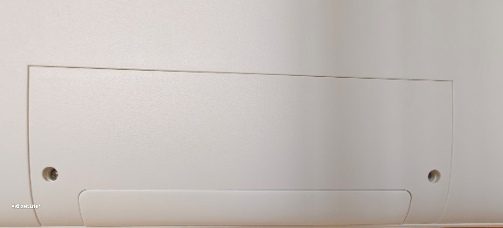 7b 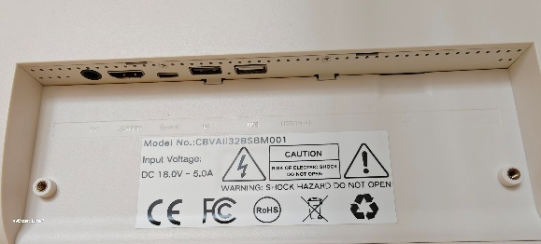
Adjusting Angle and Height
To achieve a better viewing experience, the monitor can be adjusted for tilt (front-back tilt
of -20° to 20°), swivel (left-right swivel of -15° to 15°), rotation (clockwise rotation of 90°),
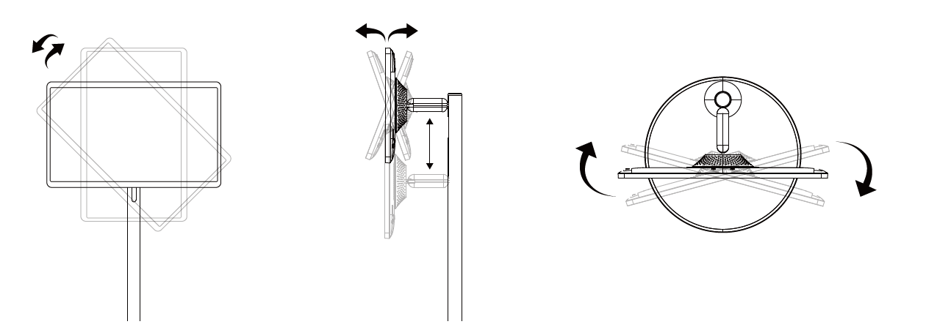
and height (vertical adjustment of 180mm).
Port Connection Instructions
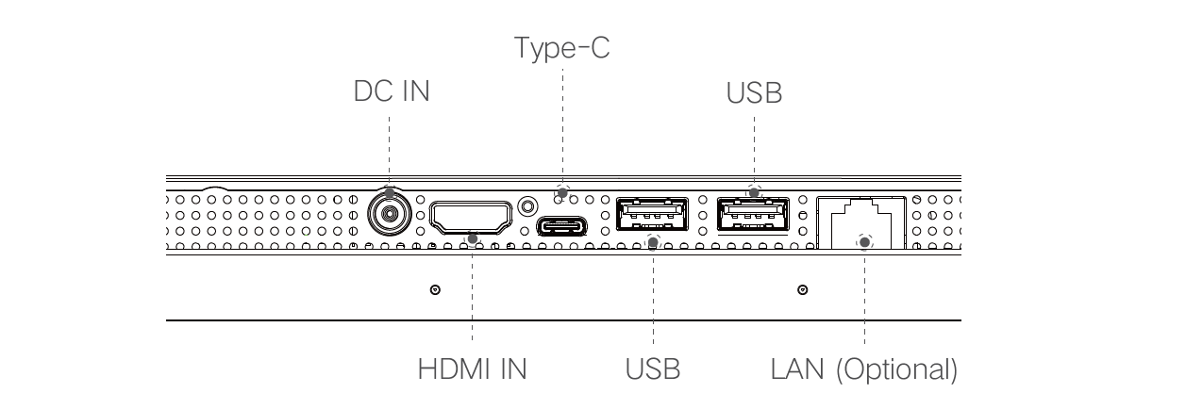
DC IN: When the battery is connected, it cannot be recharged, nor can it power the device,
When the battery is unconnected, Plugging in an adapter can start the device, But it cannot be charged.
HDMI IN: Connect to an external high-definition video signal input.
Type-C: Can be connected to a Type-C docking station, such as USB flash drives, mice, etc.
Only the ADB function is supported. (RK3576S )
USB x 2 : Connect to USB storage devices or a mouse and keyboard receiver.
LAN (Optional): Used for connecting router to realize the function of accessing the Internet.
Charging the battery
Please use the included power adapter only to charge the battery. The charging port is located at the base of the stand towards the rear end.
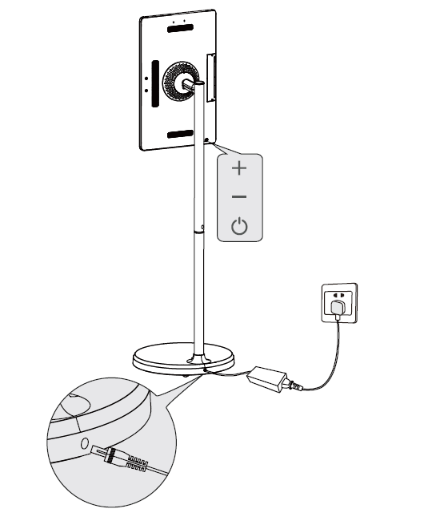

The product's stand contains a built-in rechargeable battery that can be used for a period
of time without connecting to other power sources.
When the charger is plugged into the DC port on the stand, the power indicator light will turn red. As the battery is charged, the power indicator light will turn green when it is fully charged. After unplugging the charger, the power indicator light will turn blue, indicating that the battery is providing power to the display.
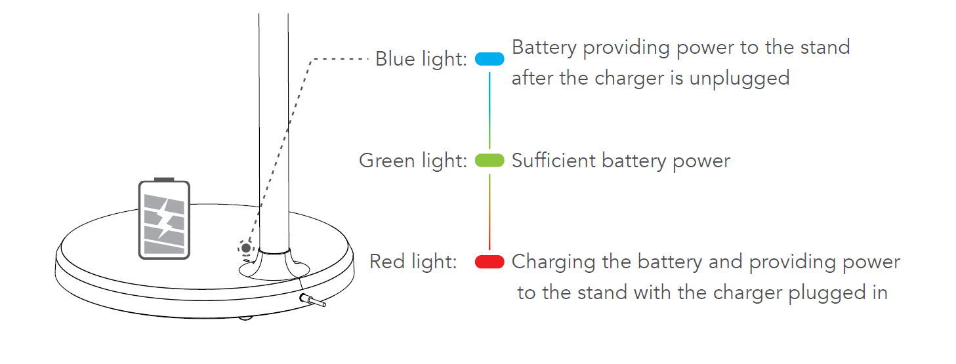
Note:
It takes approximately 6 hours to fully charge the battery while using the device at the
same time, and approximately 4 hours to fully charge the battery when the device is turned
off. After the battery is fully charged, the device's battery life is approximately 4-5 hours.
The battery life and battery runtime are proportional to the device usage time.
To extend the battery life, it is recommended to charge the battery after using it for a
period of time. After the battery is fully charged, do not leave it in a fully charged state
for a long time, and do not charge the battery under extreme conditions.
Anti-Slip Stand Instructions
Option A: Anti-slip device for stationary use or inclined surfaces.
Remove the original screw at the marked position where the anti-slip device will be installed.
Insert the PM4×16mm screw into the foot pad.
Align the screw head with the hole and tighten using a screwdriver.
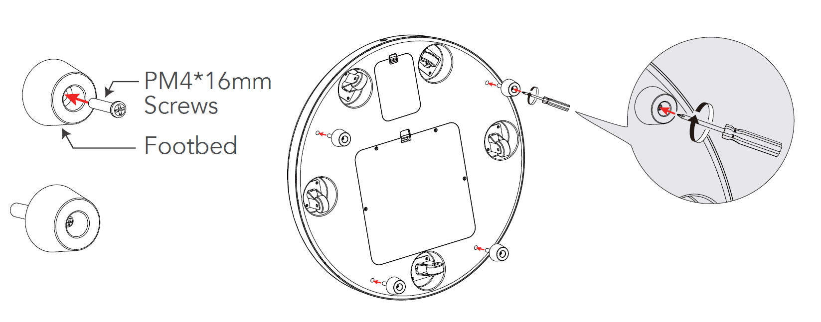
Option B: Anti-slip device for stationary applications or sloped surfaces.
Apply the double-sided tape to the back of the anti-slip foot pad.
Align and firmly press the foot pad onto the designated position of the base
(as shown in the diagram).
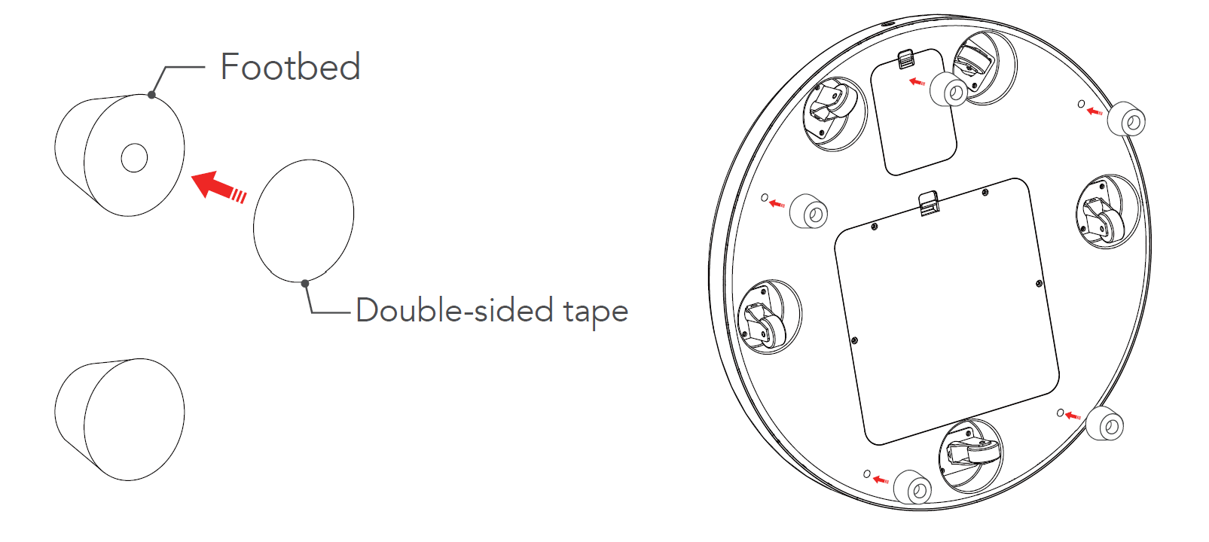

Instructions for using the remote control
1. On the main page, click the settings button located in the top right corner.
2. Click on "Connected Devices"
3. Click on "+ Pair with Device"
4. Simultaneously press and hold the Return and Play/Pause buttons on the
remote control until the remote control indicator light flashes continuously, then release
the buttons.
5. A new connected device"Remote Controller" will appear below "Available Devices",
select "Remote Controller" to pair the device.
6. When prompted to pair, click "Pair" to complete the remote control setup.
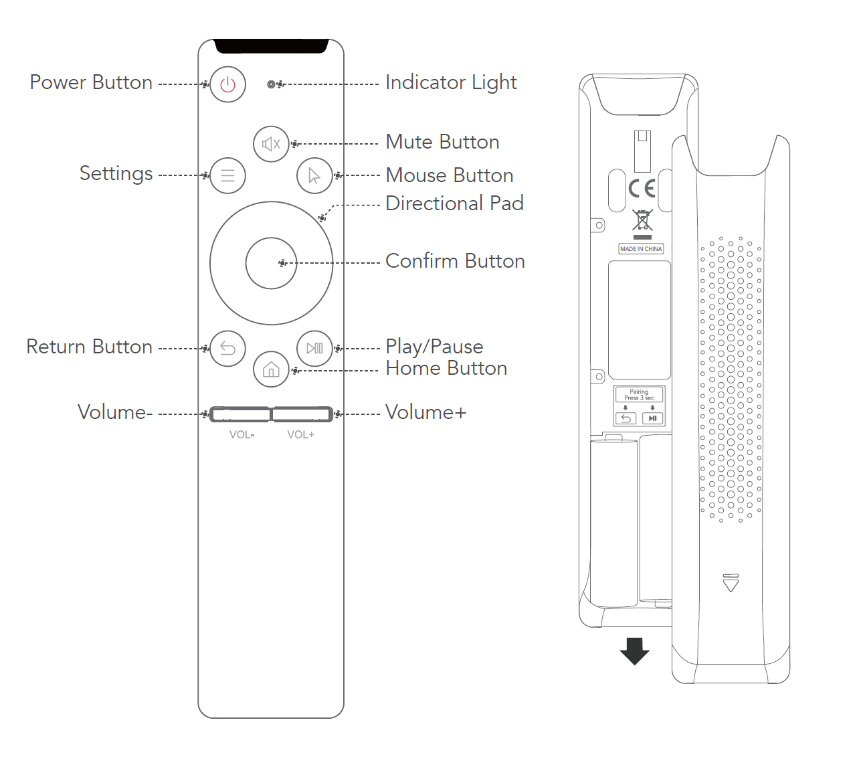

Desktop Stand assembly instructions
Step 1
Using the screws provided fix the vesa mount bracket onto the display
1a 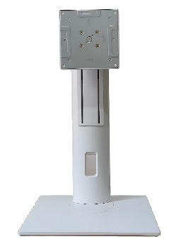1b 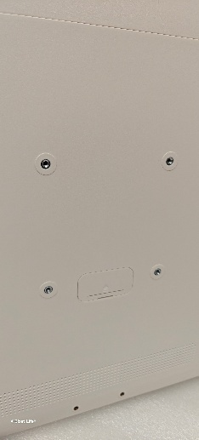
Step 2
To power the display use the DC charger provided and plug it into the DC port on the back of display (depending on your location you would have been supplied your local IEC Plug).
2a 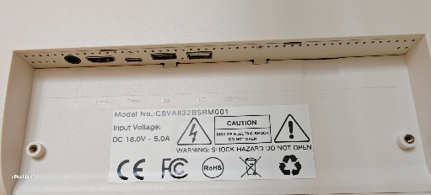 2b 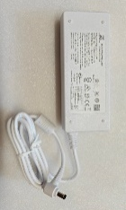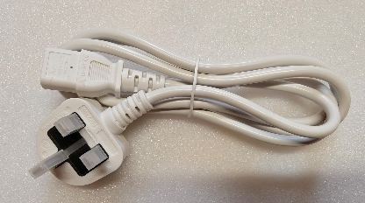

Wall Mount assembly instructions
Step 1
Unscrew the nut on the vesa mount bracket. You will then have one part for wall fixing and one part for display attachment.
Attach the bracket firmly to the wall at your desired height, ensuring it is level and properly anchored for safety. Once mounted, tighten the nut from bracket one to bracket 2 then carefully hang the display onto the wall bracket, checking that it is stable and securely fixed in place. Secure the VESA mount bracket to the back of the display using the screws provided.
1a 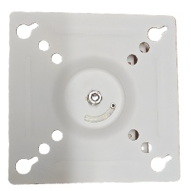 1b 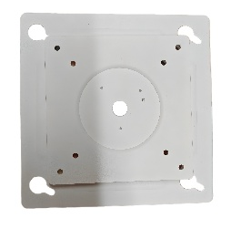

Screen Mirroring(MIX Cast)
Wireless screen mirroring, supports multiple protocols: Apple AirPlay, Miracast, Android DLNA, Chromecast.
For Android phones: Phone and device are on the same network -> Phone enters the quick menu -> Click "Screen Mirroring" -> Select the name of the device to be mirrored -> Device displays phone screen, screen mirroring successful.
For iPhone: Phone and device are on the same network -> iPhone enters the control center -> Click "Screen Mirroring" -> Select the name of the device to be mirrored -> Device displays iPhone screen, screen mirroring successful.
For Windows: Computer and device are on the same network -> Windows enters settings
-> System -> Screen -> Multiple displays -> Click "Connect to a wireless display" -> Select the name of the device to be mirrored -> Device displays screen, screen mirroring successful.
For Mac: Computer and device are on the same network -> Mac enters preferences -> Display -> Add Display -> Select the name of the device to be mirrored -> Device displays screen, screen mirroring successful.
Audio and video push: Mirroring device and device are on the same network -> Mirroring device enters video app -> Select video -> Click "Screen Mirroring Icon" in the upper right corner of the video -> Select the name of the device to be mirrored -> Device displays video screen, screen mirroring successful.

Quickshare app
Click on the Quickshare APP (USB Display) icon on main screen (You need to turn on the hotspot function first) - scan the TWO-DIMENSIONAL code in the lower left corner to download the screen casting software for screen casting.
Click the setting icon in the upper right corner to set the screen casting function.
Screen casting function setting interface, as shown below:
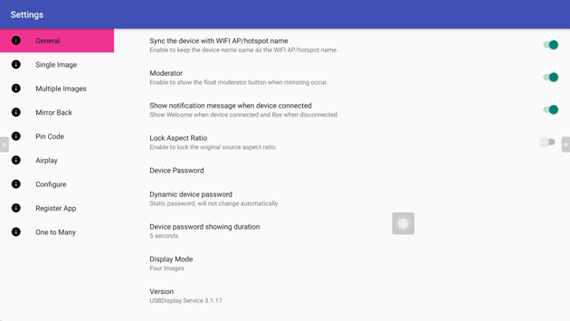
Moderator: After opening this option, a hover menu will be added to facilitate host management of screen casting, as shown below:
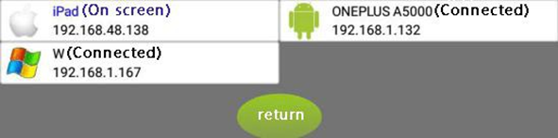
Show notification message when device connected: When the screen casting device is turned on, a welcome message will pop up. When the screen casting device is disconnected, a goodbye message will pop up.
Device Password: The default screen transmission password is 12345678, which can be changed. Dynamic device password: You can set the password to change periodically.
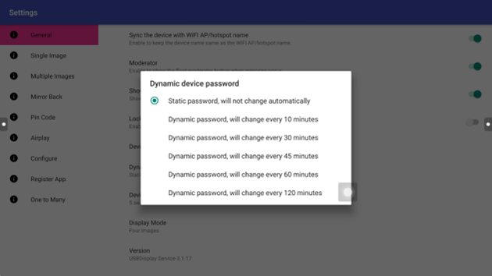
Introduction to single screen projection:
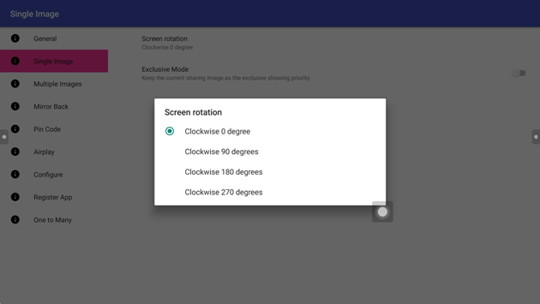
When a single screen is cast, you can manually rotate the exclusive mode of the cast screen. With exclusive mode on, when a device throws a screen, no other device can squeeze it down.
Multi-screen casting Settings:
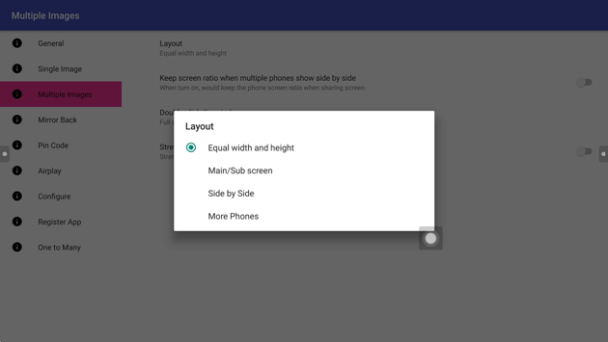
Multi-screen layout: the default multi-screen screen, the display screen is equal proportion; If the display ratio of one screen casting signal is larger than that of the other screen casting signals, the main screen can be switched.
Multi-screen: Full screen display by default.
Two-screen screen setting: In dual-phone screen casting, the two sides will not be displayed because of the display proportion. After this option is turned on, the display proportion will be stretched and the display will be in full screen.
Screen anti-mirror setting:
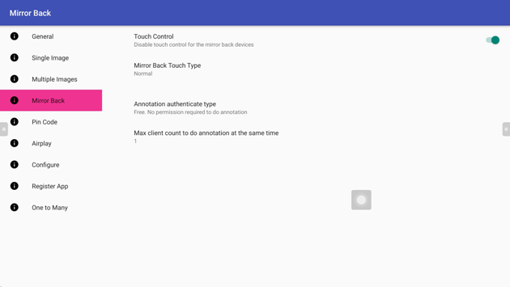
After successful anti-mirror, the screen of the Android phone will display a large screen, and then the touch of the phone can control the large screen. If the touch control is turned off, the large screen cannot be controlled.
Request Annotation Authorization Type Allows you to set the annotation permission in anti-mirror mode
Maximum Number of Customers who annotate at the same time Allows you to set the number of customers who annotate at the same time. However, only one person can write to another person
Reverse Mirror on Windows: Click Reverse Mirror after the connection.

Screen projection code setting:
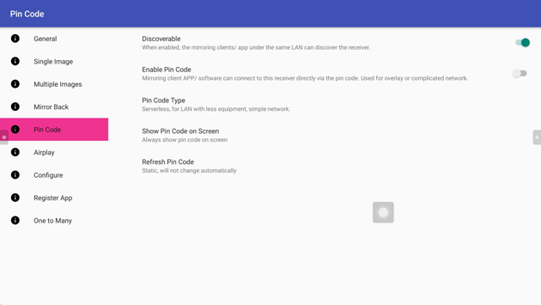
After the screen casting code function is enabled, the six-digit screen casting code is displayed in the upper right corner of the screen.
Registration procedure(You need to connect to the Internet). After connecting to the network, the system automatically registers, and a pop-up prompts you to register.
3.Introduction to wireless screen transmission
3.1 Screen projection for Apple devices:
Connect the Apple device to the hot spot AndroidAP-XXXX of the conference machine, and then open the AirPlay image of the mobile phone to realize screen transmission.
3.2 Screen projection for Android devices:
The mobile phone scans the QR code displayed at the lower left corner of the page and then links the conference machine to the hot spot AndroidAP- xxxx, and then opens the client, click the search at the lower right corner to connect the corresponding device or scan the screen.
After the mobile phone is connected, on the connection page, you can select screen casting, virtual mouse remote control, screenshot, anti-mirror, video, audio and music, picture, and document for operation.
Click document to push PPT, Word document, Excel table and PDF to play in the machine. After the document is pushed, the mobile phone jumps to the virtual mouse page: Touch the blank area of the virtual mouse to control the large screen and touch the right and bottom of the virtual mouse to slide the document.
3.3 Computer equipment software screen projection:
In the case of no screen transmitter, the PC image projection is realized by running green software, and the function effect is similar to the screen transmitter. The screen laptop to connect to the Internet, open a web browser input address http://www.usb01.com, pop-up download page, click download Windows client, and then double-click on the run, the machine list will list the current notebook can be found in your local area network (LAN) intelligent meeting, Double-click the specified machine or IP address to automatically connect to the device.
This section describes PC hardware screen transmission
First open the wifi hotspot of android board, and then connect the screen transmitter to the USB interface of Android board for pairing registration. After registering successfully, the following interface will pop up:
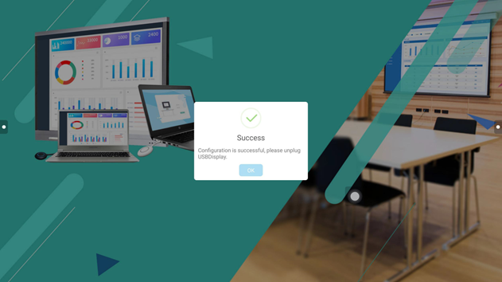
Note: Before matching, turn on the hotspot and then connect to the screen projector for matching.
Connect the registered screen transmitter to the USB port of the computer. When "Shareable" is displayed on the interface, press the screen transmitter to see the corresponding sharing screen on the meeting tablet.
When the screen transmitter is successfully connected to the machine, a circular green button will appear in the upper left corner, and the number displayed represents the number of screen transmitters connected to the machine. Click to expand the display host mode, and repeatedly click the next screen of the device in the screen projection or click the connected device to start screen transmission, as shown below:
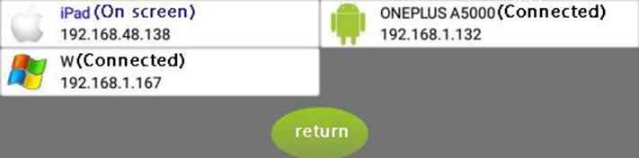
In the process of screen transmission, after the lock is checked, other users' computer screens cannot pre-empt the user screen that is being transmitted.
Touch return, double screen control:
Use the screen projector to cast the screen. The PC can operate the large screen, and the PC can operate the large screen.
In the case of the device connected to the Internet, the opportunity to automatically update according to the background update situation, if discover the firmware version of the Quickshare and the device firmware version does not match, will pop up on the computer screen transfer end tip version do not match, please update, the need to plug in the Quickshare into the USB port of the whole device matching can sync the versions to upgrade.
Precautions for use of screen transmitter:
When the user's computer uses the screen transmitter for the first time, some computers will automatically install the driver, quickshare device will automatically install and run; If the computer does not automatically install the driver, you can click (computer) → removable storage device, double-click the drive letter CD drive (Quickshare).
Note: in Windows10, you need to turn off the firewall before installing the driver.
After the driver is installed, the lower right corner of the computer will display a prompt: press the screen can be transmitted.
Note: In some computer systems, due to anti-virus software interception, even if it is not the first time to use, the screen transmitter can not run by itself. In this case, you need to execute the main program of Quickshare.

